**Bug-id: BI01**

**Bug:** The page becomes unresponsive when clicking on the numbers of results.

**Severity**

High

**Issue Type**

Crash

**Frequency**

Every Time

**Environment**

All Browsers

**Action Performed**

1. Open [**https://academybugs.com**](https://academybugs.com/)
2. Click the Find Bugs link on the navigation bar
3. Click on the buttons to show a certain number of results at the top left

**Expected Result**

The selected number of results is displayed according to the clicked buttons

**Actual Result**

The page freezes when clicking on the numbers of results

**Attachments**

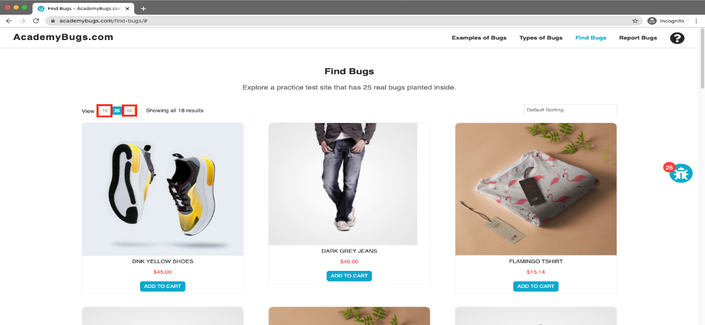

**Bug-id: BI02**

**Bug:** he page freezes when changing the currency.

**Severity**

High

**Issue Type**

Crash

**Frequency**

Every Time

**Environment**

All Browsers

**Action Performed**

1. Open [**https://academybugs.com**](https://academybugs.com/)
2. Click the Find Bugs link on the navigation bar
3. Open a product
4. Change the currency in the right side menu

**Expected Result**

The currency is changed as expected

**Actual Result**

The page freezes when changing the currency

**Attachments**

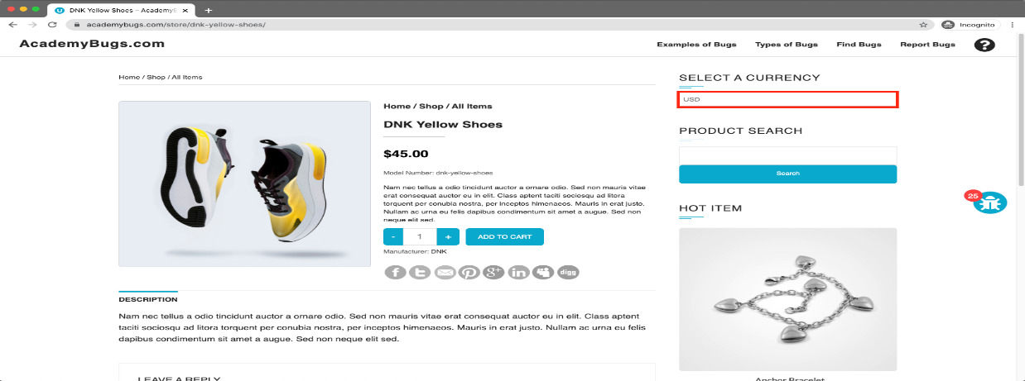

**Bug-id: BI03**

**Bug:** The twitter share button in the product details page is broken.

**Severity**

Medium

**Issue Type**

Functional

**Frequency**

Every Time

**Environment**

All Browsers

**Action Performed**

1. Open [**https://academybugs.com**](https://academybugs.com/)
2. Click the Find Bugs link on the navigation bar
3. Open a product
4. Click the twitter share button

**Expected Result**

The twitter share button shows an appropriate page

**Actual Result**

The twitter share button shows an error page

**Attachments**

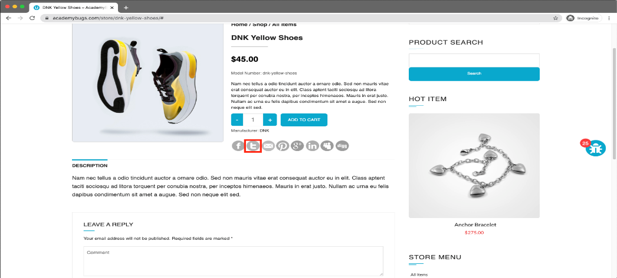

**Bug-id: BI04**

**Bug:** the image is not completely displayed.

**Severity**

Medium

**Issue Type**

Visual

**Frequency**

Every Time

**Environment**

All Browsers

**Action Performed**

1. Open [**https://academybugs.com**](https://academybugs.com/)
2. Click the Find Bugs link on the navigation bar
3. Click on "Dark Grey Jeans"

**Expected Result**

The product image fills the box entirely

**Actual Result**

The image has a white space on the right

**Attachments**

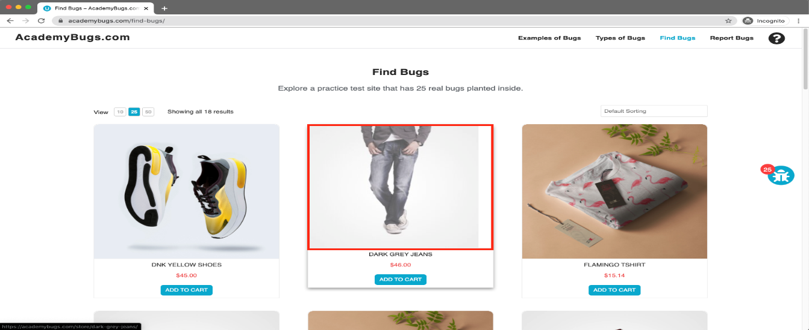

**Bug-id: BI05**

**Bug:** the short description and description of the product are not in English.

**Severity**

Medium

**Issue Type**

Content

**Frequency**

Every Time

**Environment**

All Browsers

**Action Performed**

1. Open [**https://academybugs.com**](https://academybugs.com/)
2. Click the Find Bugs link on the navigation bar
3. Open a product

**Expected Result**

The short description and description of the product are in English

**Actual Result**

The short description and description of the product are not in English

**Attachments**

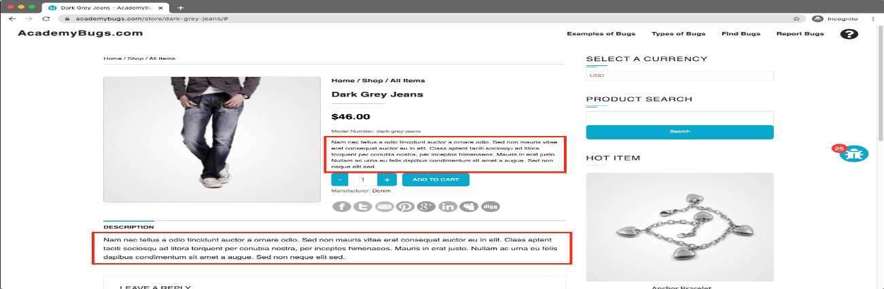

**Bug-id: BI06**

**Bug:** The filter by price doesn't work in the product details page.

**Severity**

Medium

**Issue Type**

Functional

**Frequency**

Every Time

**Environment**

All Browsers

**Action Performed**

1. Open [**https://academybugs.com**](https://academybugs.com/)
2. Click the Find Bugs link on the navigation bar
3. Open a product
4. On the right side menu find the Filter by Price section
5. Select any of the price ranges

**Expected Result**

A list of products in the selected price range is shown

**Actual Result**

The same page reloads

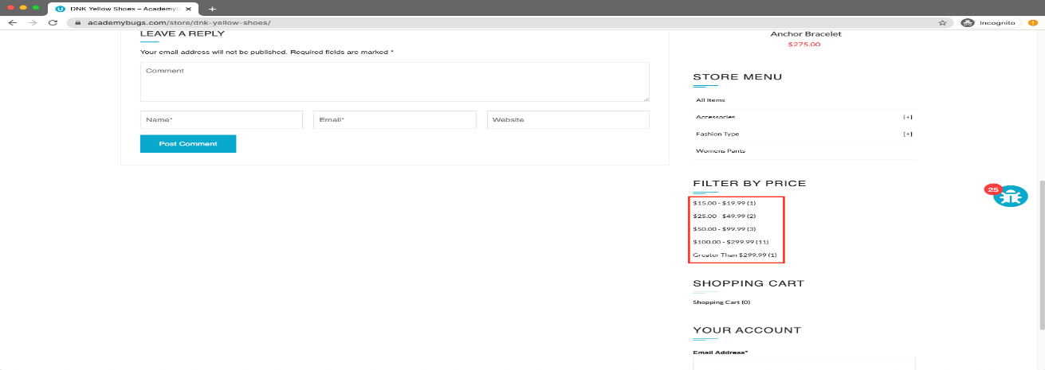

**Bug-id: BI07**

**Bug:** Item images have unnecessary space underneath.

**Severity**

Low

**Issue Type**

Visual

**Frequency**

Every Time

**Environment**

All Browsers

**Action Performed**

1. Open [**https://academybugs.com**](https://academybugs.com/)
2. Click the Find Bugs link on the navigation bar
3. Open a product
4. Find the Store Menu section in the right side menu
5. Choose All Items

**Expected Result**

Item images have no space underneath

**Actual Result**

Item images have unnecessary space underneath

**Attachment**

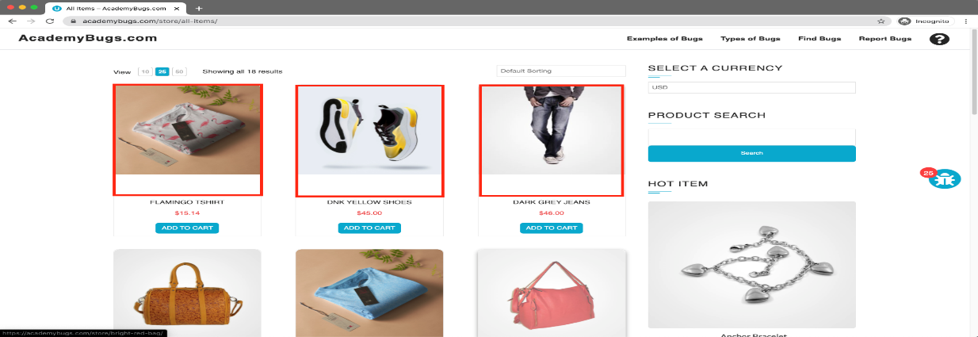

**Bug-id: BI08**

**Bug:** The grand total is $100 more than the sum of all products in the cart.

**Severity**

Critical

**Issue Type**

Functional

**Frequency**

Every Time

**Environment**

All Browsers

**Action Performed**

1. Open [**https://academybugs.com**](https://academybugs.com/)
2. Click the Find Bugs link on the navigation bar
3. Add one or more products to the cart
4. Click the "View cart" link on top of the page, or click "Continue to Shipping" in the checkout details page

**Expected Result**

The grand total is equal to the sum of all products in the cart

**Actual Result**

The grand total is $100 more than the sum of all products in the cart

**Attachment**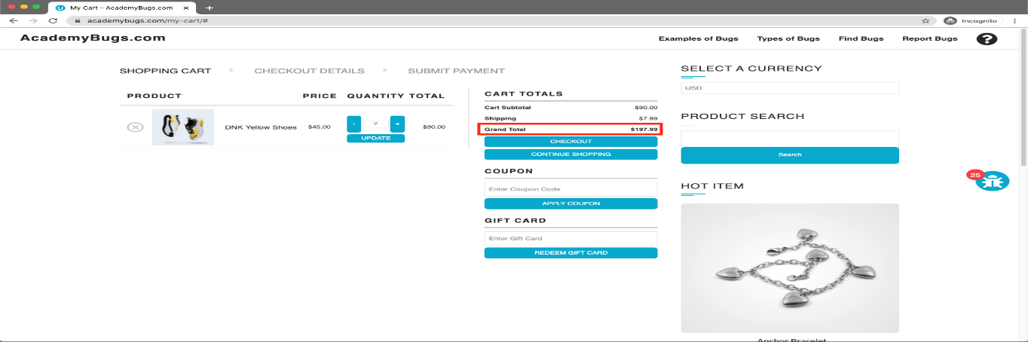

**Bug-id: BI09**

**Bug:** The product quantity cannot be increased past 2.

**Severity**

High

**Issue Type**

Functional

**Frequency**

Every Time

**Environment**

All Browsers

**Action Performed**

1. Open [**https://academybugs.com**](https://academybugs.com/)
2. Click the Find Bugs link on the navigation bar
3. Add one or more products to the cart
4. Click the "View cart" link on top of the page
5. Set the products quantity to 3 or more
6. Click "update" below

**Expected Result**

The product quantity can be increased past 2

**Actual Result**

When clicking on the update button the product quantity becomes 2 again

**Attachments**

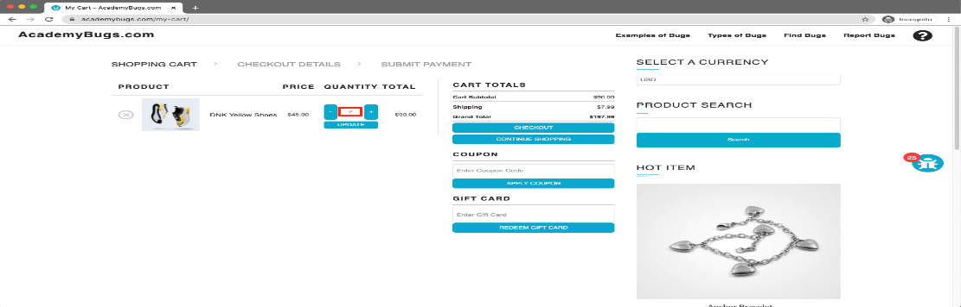

**Bug-id: BI10**

**Bug:** There is big space before the last letter in "Return to Store".

**Severity**

Low

**Issue Type**

Content

**Frequency**

Every Time

**Environment**

All Browsers

**Action Performed**

1. Open [**https://academybugs.com**](https://academybugs.com/)
2. Click the Find Bugs link on the navigation bar
3. Open a product
4. Open the cart at the bottom of right side menu
5. Clear the cart if there are any items

**Expected Result**

The caption of the "Return to Store" button is written with even spacing between letters

**Actual Result**

There is too much space before the last letter in "Return to Store"

**Attachment**

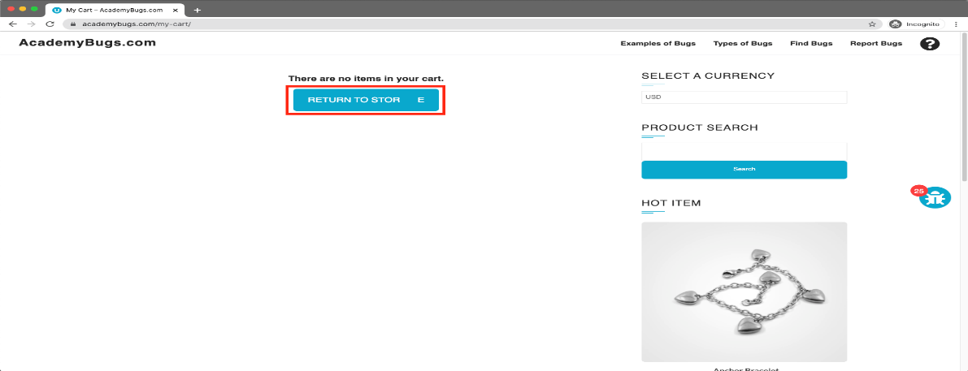

**Bug-id: BI11**

**Bug:** the page becomes unresponsive when clicking on the Post Comment button.

**Severity**

High

**Issue Type**

Crash

**Frequency**

Every Time

**Environment**

All Browsers

**Action Performed**

1. Open [**https://academybugs.com**](https://academybugs.com/)
2. Click the Find Bugs link on the navigation bar
3. Open a product
4. Scroll down to the Leave a Reply section
5. Fill out the comment form
6. Click "Post Comment"

**Expected Result**

The comment is posted under the product

**Actual Result**

The page becomes unresponsive when clicking on "Post Comment"

**Attachment**

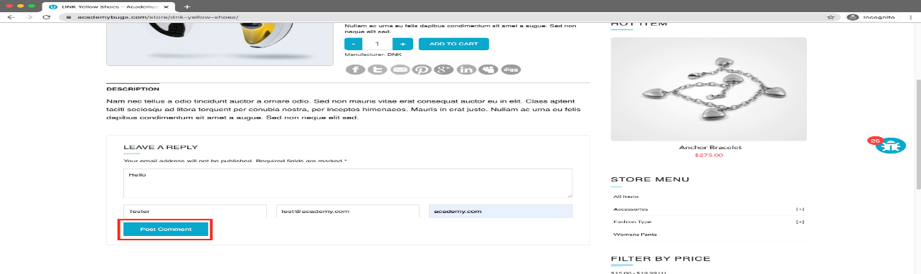

**Bug-id: BI12**

**Bug:** The Sign in button overlaps the footer.

**Severity**

Low

**Issue Type**

Visual

**Frequency**

Every Time

**Environment**

All Browsers

**Action Performed**

1. Open [**https://academybugs.com**](https://academybugs.com/)
2. Click the Find Bugs link on the navigation bar
3. Open a product
4. Scroll down to the bottom of the right side menu

**Expected Result**

The Sign in button is above the footer

**Actual Result**

The Sign in button overlaps the footer

**Attachments**

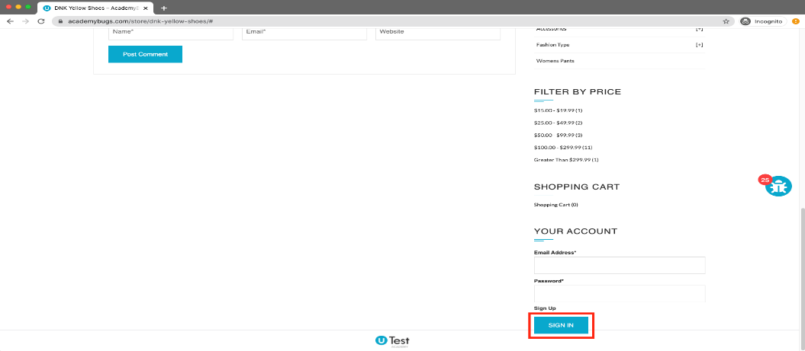

**Bug-id: BI13**

**Bug:** The manufacturer link in the product details page is broken.

**Severity**

Medium

**Issue Type**

Functional

**Frequency**

Every Time

**Environment**

All Browsers

**Action Performed**

1. Open [**https://academybugs.com**](https://academybugs.com/)
2. Click the Find Bugs link on the navigation bar
3. Open a product
4. Click the manufacturer link under the quantity

**Expected Result**

The manufacturer link shows an appropriate page

**Actual Result**

The manufacturer link opens an error page

**Attachments**

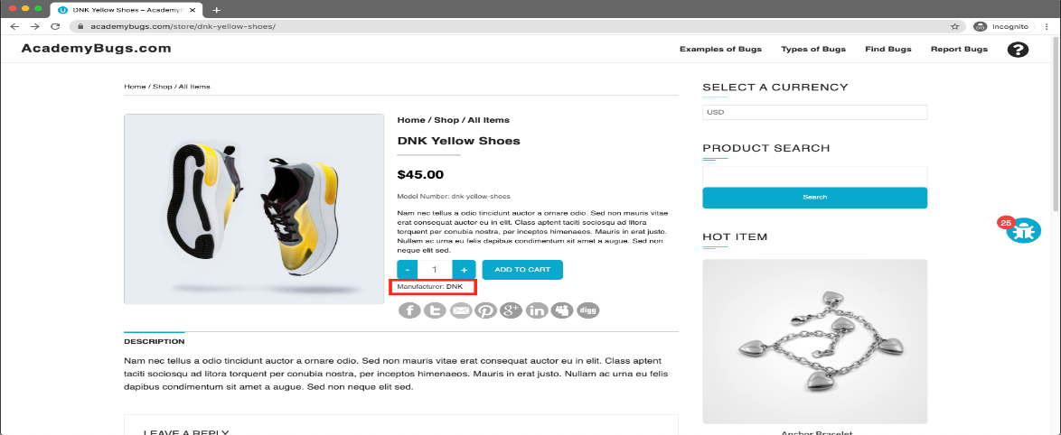

**Bug-id: BI14**

**Bug:** There are unreadable symbols in the shopping cart popup.

**Severity**

Low

**Issue Type**

Content

**Frequency**

Every Time

**Environment**

All Browsers

**Action Performed**

1. Open [**https://academybugs.com**](https://academybugs.com/)
2. Click the Find Bugs link on the navigation bar
3. Add one or more products to the cart
4. Click "View Cart" on top of the page
5. Scroll down to the Shopping Cart section of the right side menu
6. Hover over the Shopping Cart caption

**Expected Result**

All characters are clear to a regular user

**Actual Result**

There are unreadable symbols in the shopping cart popup

**Attachments**

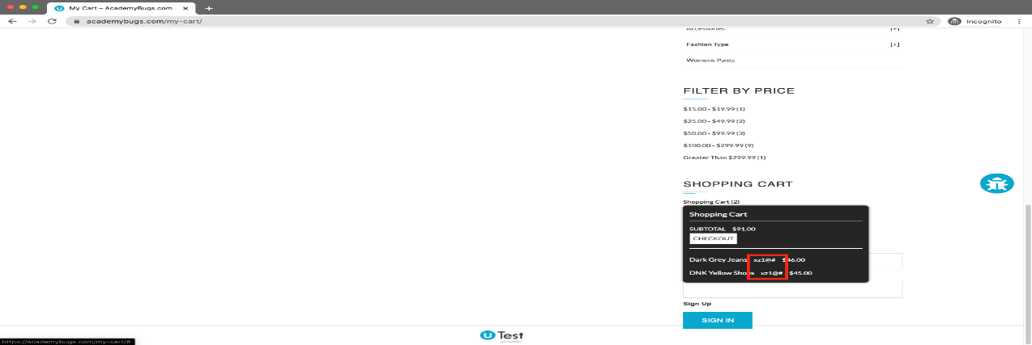

**Bug-id: BI15**

**Bug:** the product in the Hot Item section keeps loading.

###### Severity

High

###### Issue Type

Performance

###### Frequency

Every Time

###### Environment

All Browsers

###### Action Performed

1. Open [**https://academybugs.com**](https://academybugs.com/)
2. Click the Find Bugs link on the navigation bar
3. Open a product
4. Open the product in the Hot Item section of the right side menu

###### Expected Result

The product in the Hot Item section is displayed

###### Actual Result

The page loads infinitely

###### Attachments

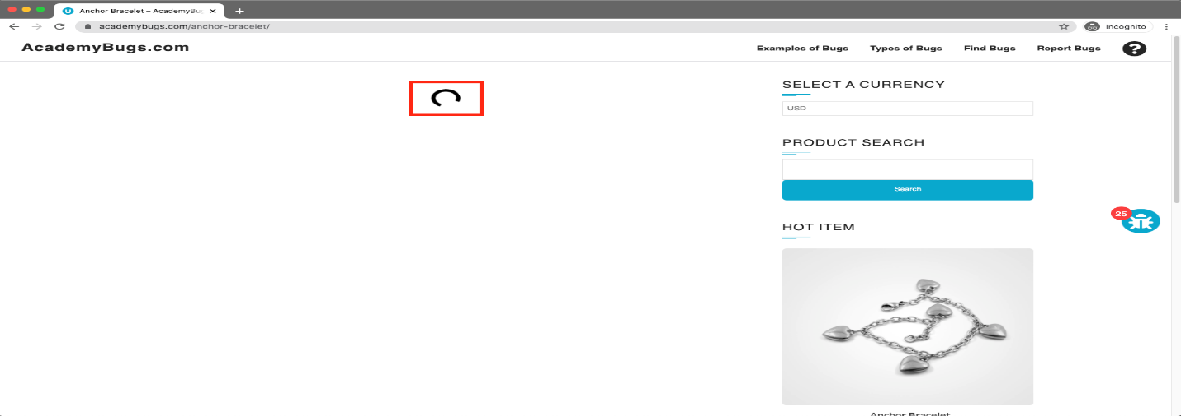

**Bug-id: BI16**

**Bug:** the text under the New User section is not in English.

###### Severity

Low

###### Issue Type

Content

###### Frequency

Every Time

###### Environment

All Browsers

###### Action Performed

1. Open [**https://academybugs.com**](https://academybugs.com/)
2. Click the Find Bugs link on the navigation bar
3. Open a product
4. Scroll down to the bottom of the right side menu
5. Click "Sign In" to open the sign in page

###### Expected Result

The text under the New User section is in English

###### Actual Result

The text under the New User section is in another language

###### Attachments

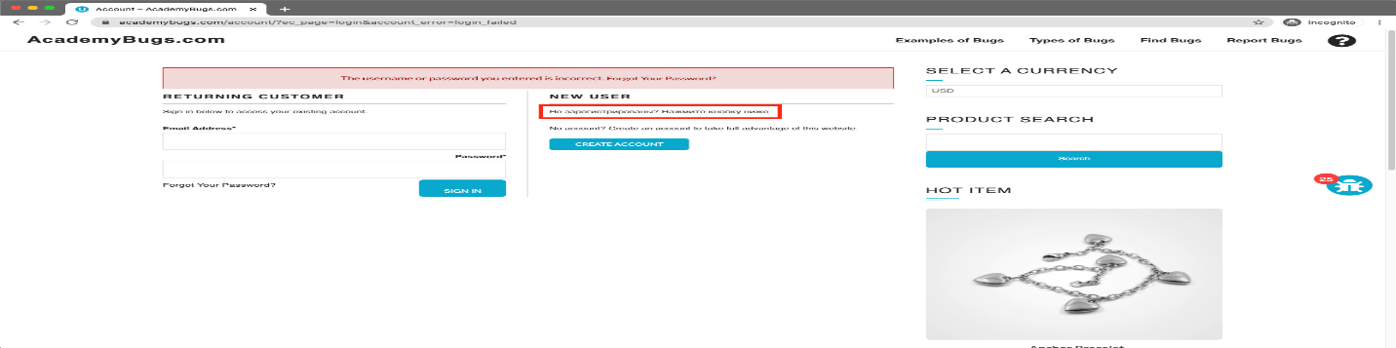

**Bug-id: BI17**

**Bug:** the caption of the Sign in button is misaligned vertically.

###### Severity

Low

###### Issue Type

Visual

###### Frequency

Every Time

###### Environment

All Browsers

###### Action Performed

1. Open [**https://academybugs.com**](https://academybugs.com/)
2. Click the Find Bugs link on the navigation bar
3. Open a product
4. Scroll to the bottom and find the sign in form in the right side menu
5. Enter any login and password that are not registered and click "Sign In"

###### Expected Result

The caption of the Sign in button is centered vertically

###### Actual Result

The caption of the Sign in button is misaligned vertically

###### Attachments

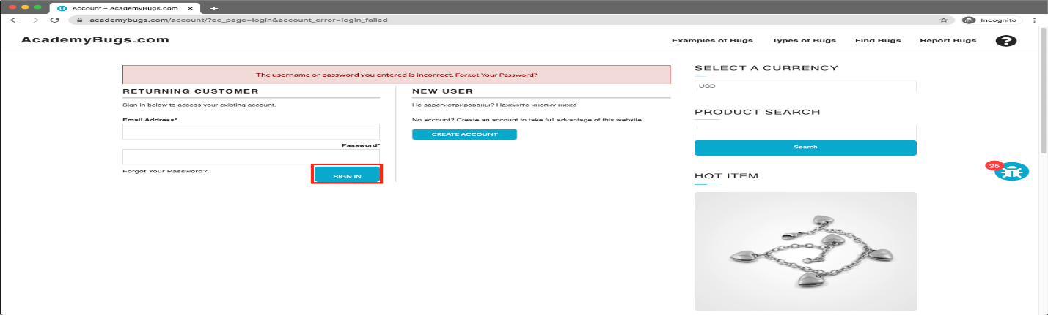

**Bug-id: BI18**

**Bug:** the yellow and orange colors of the product are misspelled.

###### Severity

Low

###### Issue Type

Content

###### Frequency

Every Time

###### Environment

All Browsers

###### Action Performed

1. Open [**https://academybugs.com**](https://academybugs.com/)
2. Click the Find Bugs link on the navigation bar
3. Open a product with color options
4. Choose the Yellow and Orange colors

###### Expected Result

The yellow and orange colors are spelled correctly

###### Actual Result

Yellow is misspelled as "Yelow" and Orange as "Orang"

###### Attachments

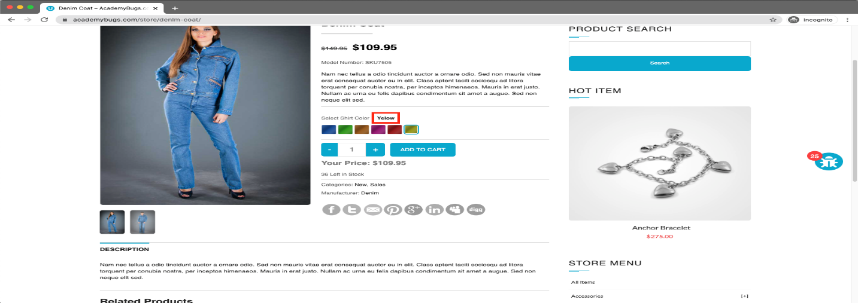

**Bug-id: BI19**

**Bug:** the billing address loads infinitely.

###### Severity

Medium

###### Issue Type

Performance

###### Frequency

Every Time

###### Environment

All Browsers

###### Action Performed

1. Open [**https://academybugs.com**](https://academybugs.com/)
2. Click the Find Bugs link on the navigation bar
3. Open a product
4. Sign up if you are not signed up or log in at the bottom of right side menu
5. At the bottom of the right side menu select Dashboard
6. Scroll up to the Billing Address section

###### Expected Result

The Billing Address section shows appropriate info

###### Actual Result

The Billing Address section loads infinitely

###### Attachments

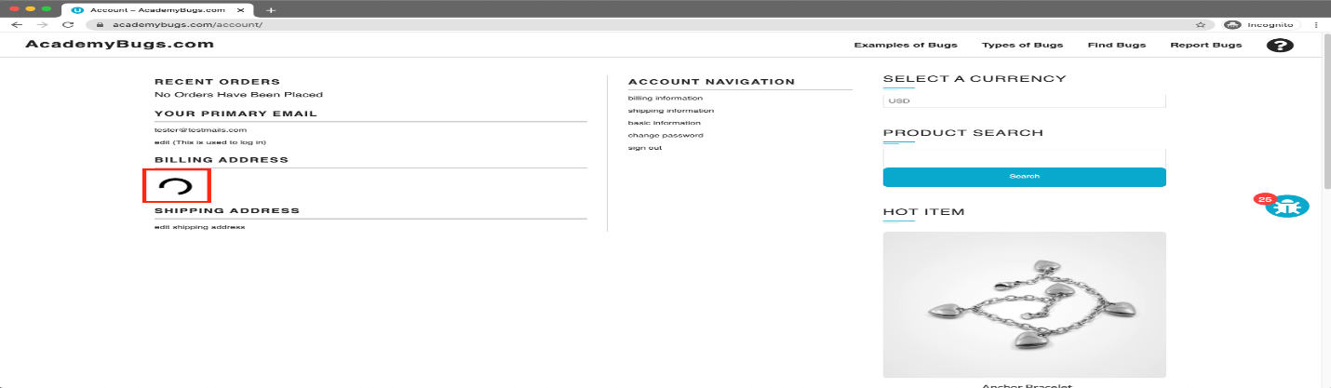

**Bug-id: BI20**

**Bug:** the order history loads infinitely.

###### Severity

High

###### Issue Type

Performance

###### Frequency

Every Time

###### Environment

All Browsers

###### Action Performed

1. Open [**https://academybugs.com**](https://academybugs.com/)
2. Click the Find Bugs link on the navigation bar
3. Open a product
4. Sign up if you are not signed up or log in at the bottom of right side menu
5. At the bottom of the right side menu select Order History

###### Expected Result

Your Order History section shows appropriate info

###### Actual Result

Your Order History section loads infinitely

###### Attachments

###### 

**Bug-id: BI21**

**Bug:** the title of the password field is misaligned.

###### Severity

Low

###### Issue Type

Visual

###### Frequency

Every Time

###### Environment

All Browsers

###### Action Performed

1. Open [**https://academybugs.com**](https://academybugs.com/)
2. Click the Find Bugs link on the navigation bar
3. Open a product
4. Scroll down to the bottom of the right side menu
5. Click "Sign in" without filling the form to open the Sign In page

###### Expected Result

The title of the password field is aligned the same as the field above

###### Actual Result

The title of the password field is not aligned the same as the field above

###### Attachments

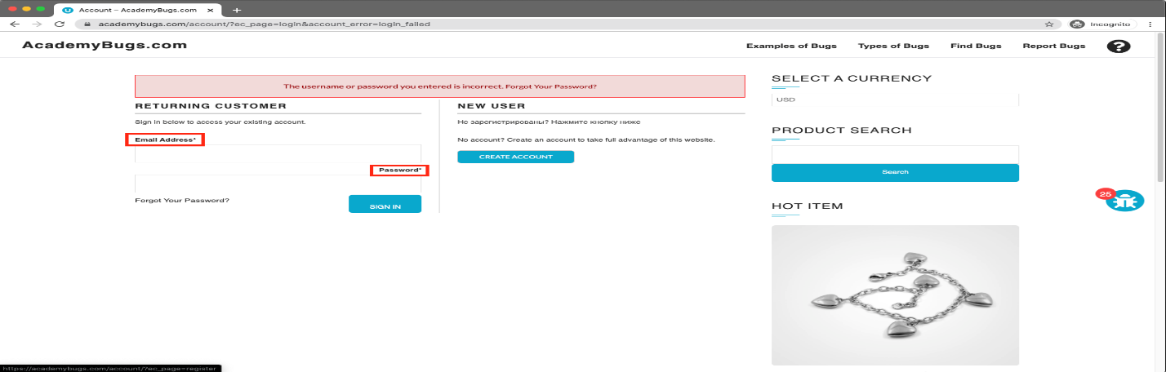

**Bug-id: BI22**

**Bug:** The page becomes unresponsive when clicking on the Retrieve Password button.

###### Severity

High

###### Issue Type

Crash

###### Frequency

Every Time

###### Environment

All Browsers

###### Action Performed

1. Open [**https://academybugs.com**](https://academybugs.com/)
2. Click the Find Bugs link on the navigation bar
3. Open a product
4. Scroll down to the Your Account section of the right side menu
5. Click "Sign Up"
6. In the Returning Customer section click "Forgot Your Password?"
7. Enter your email in the field and click "Retrieve Password"

###### Expected Result

The password is sent to the entered email

###### Actual Result

The page becomes unresponsive when clicking on "Retrieve Password" and no email is sent

###### Attachments

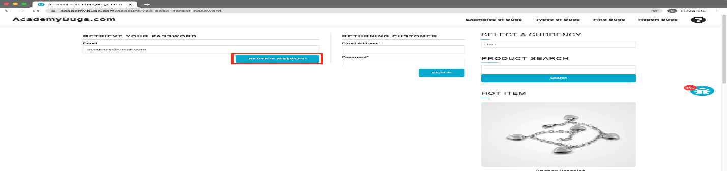

**Bug-id: BI23**

**Bug:** the billing information isn't updated.

###### Severity

High

###### Issue Type

Performance

###### Frequency

Every Time

###### Environment

All Browsers

###### Action Performed

1. Open [**https://academybugs.com**](https://academybugs.com/)
2. Click the Find Bugs link on the navigation bar
3. Open a product
4. Click "Sign Up" at the bottom of right side menu
5. Sign up with fake data if you are not signed up. Otherwise enter your credentials and log in
6. At the bottom of the right side menu select Billing Information
7. Fill out the billing information form
8. Click "Update"

###### Expected Result

Billing information is updated after filling out the form and clicking "Update"

###### Actual Result

Billing information loads infinitely after filling out the form and clicking "Update"

###### Attachments

###### 

**Bug-id: BI24**

the page freezes when increasing the product quantity having green or pink colors chosen.

###### Severity

High

###### Issue Type

Crash

###### Frequency

Every Time

###### Environment

All Browsers

###### Action Performed

1. Open [**https://academybugs.com**](https://academybugs.com/)
2. Click the Find Bugs link on the navigation bar
3. Open a product that has color options
4. Choose the pink or green color
5. Increase the product quantity by 1 or more

###### Expected Result

The quantity is increased to a desired value

###### Actual Result

The page becomes unresponsive when increasing the quantity with the pink or green colors chosen

###### Attachments

